**Question No 1**

**Q.1-a**

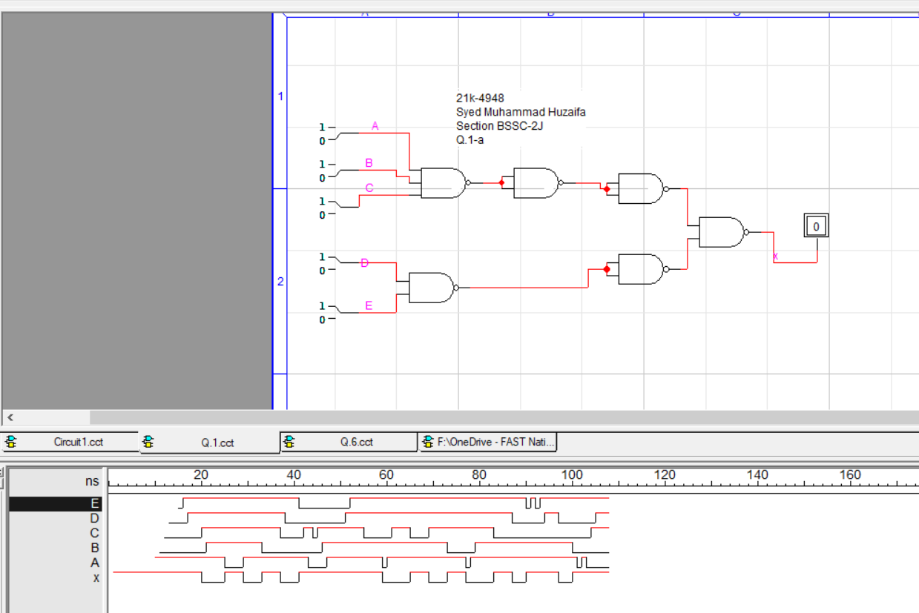

**Q1-b**

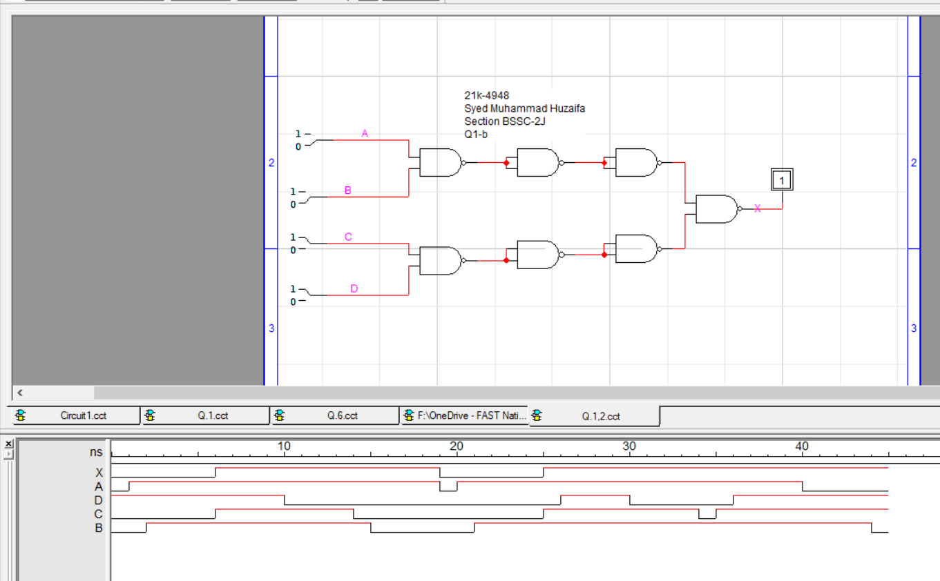

**Question No 2**

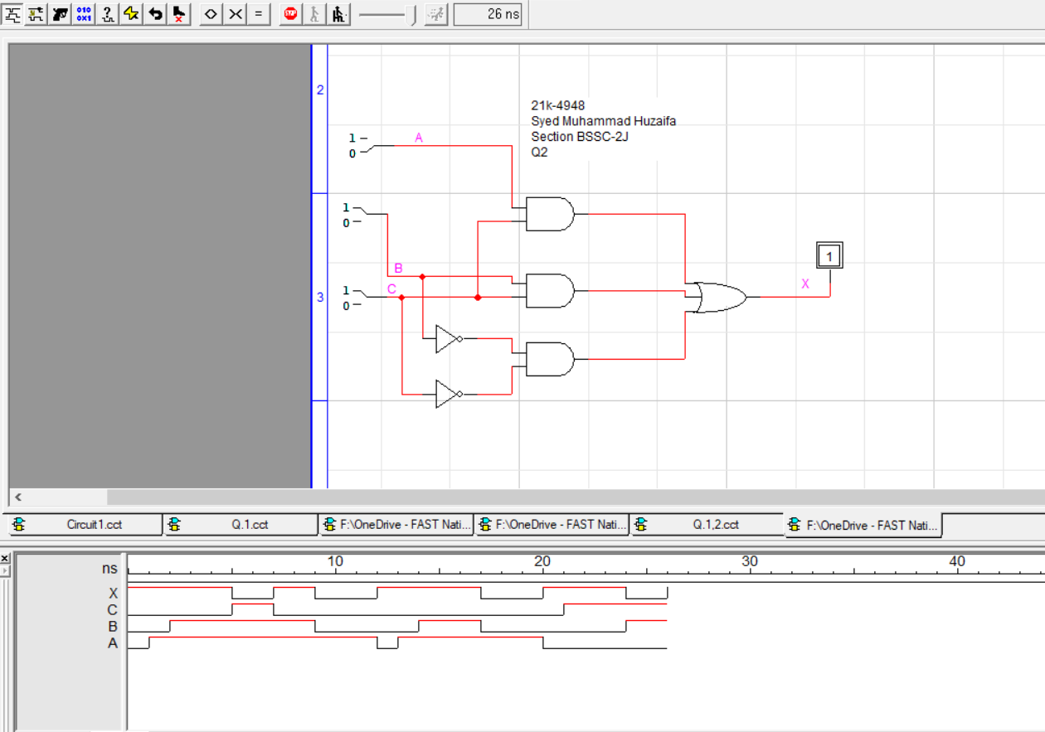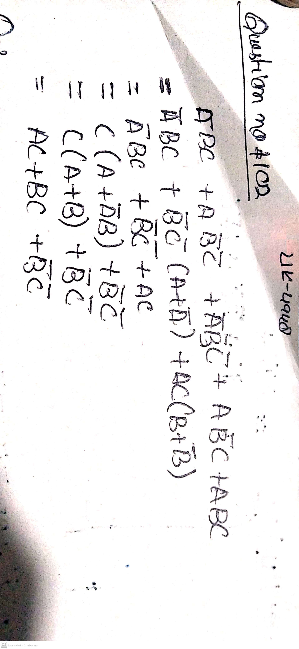

**Question No 3**

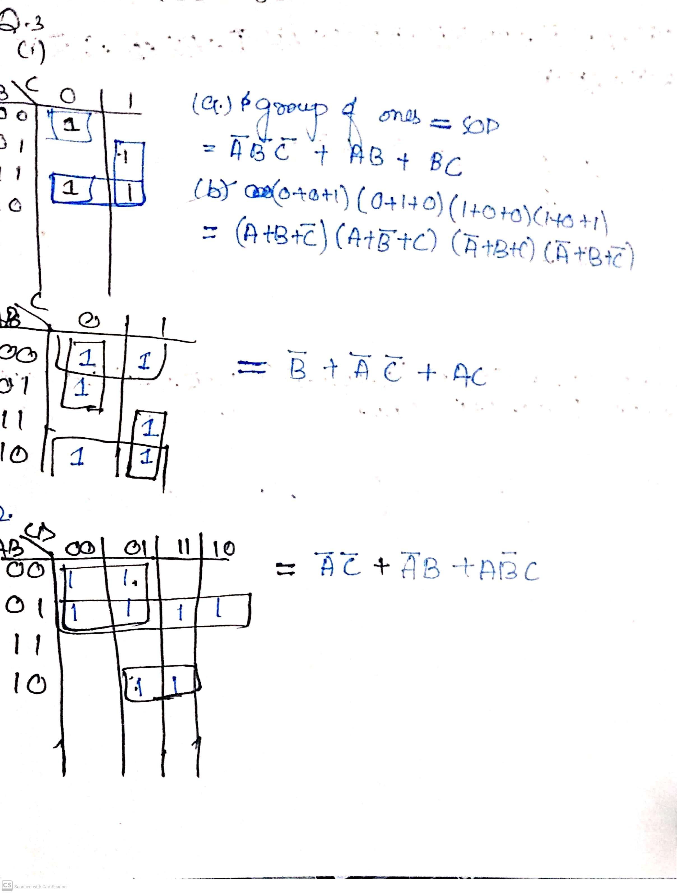

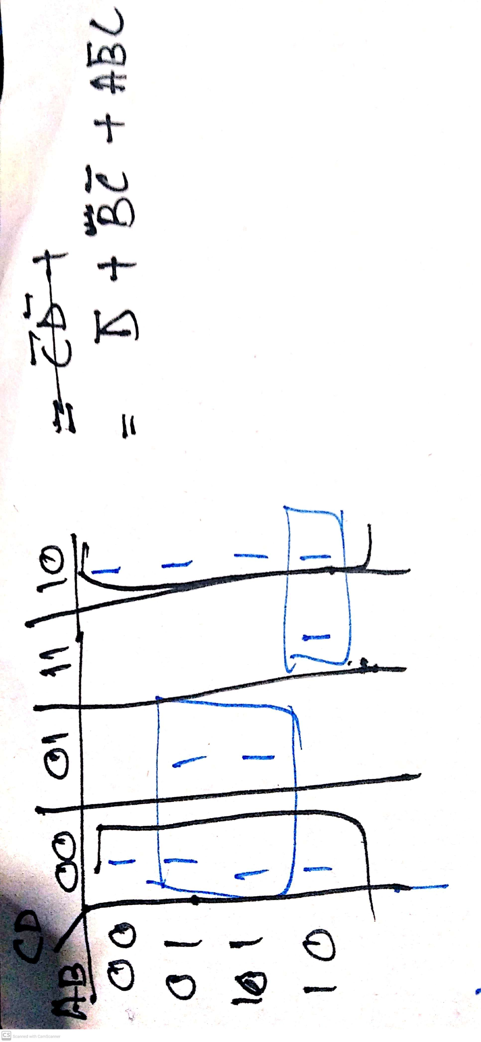

**Question No 4**

|  |  |  |  |  |
| --- | --- | --- | --- | --- |
| **A** | **B** | **C** | **D** | **X** |
| **0** | **0** | **0** | **0** | **1** |
| **0** | **0** | **0** | **1** | **0** |
| **0** | **0** | **1** | **0** | **1** |
| **0** | **0** | **1** | **1** | **1** |
| **0** | **1** | **0** | **0** | **1** |
| **0** | **1** | **0** | **1** | **0** |
| **0** | **1** | **1** | **0** | **1** |
| **0** | **1** | **1** | **1** | **0** |
| **1** | **0** | **0** | **0** | **1** |
| **1** | **0** | **0** | **1** | **0** |
| **1** | **0** | **1** | **0** | **1** |
| **1** | **0** | **1** | **1** | **1** |
| **1** | **1** | **0** | **0** | **1** |
| **1** | **1** | **0** | **1** | **0** |
| **1** | **1** | **1** | **0** | **1** |
| **1** | **1** | **1** | **1** | **0** |

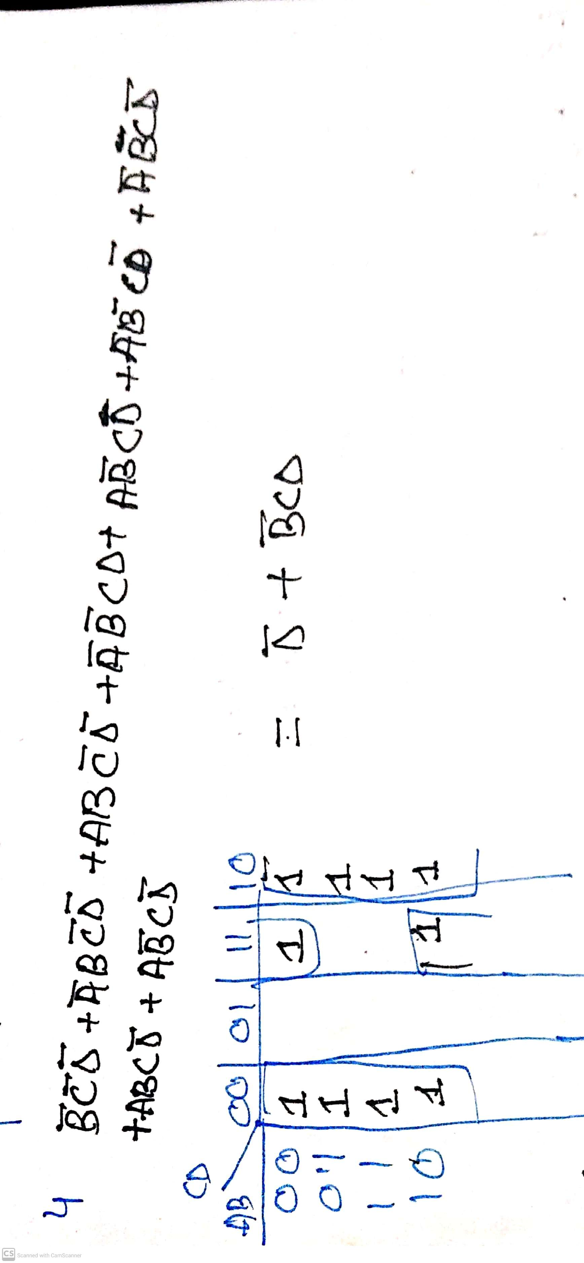

**Question No 5**

|  |  |  |  |  |
| --- | --- | --- | --- | --- |
| **A** | **B** | **C** | **D** | **X** |
| **0** | **0** | **0** | **0** | **0** |
| **0** | **0** | **0** | **1** | **1** |
| **0** | **0** | **1** | **0** | **0** |
| **0** | **0** | **1** | **1** | **1** |
| **0** | **1** | **0** | **0** | **0** |
| **0** | **1** | **0** | **1** | **1** |
| **0** | **1** | **1** | **0** | **1** |
| **0** | **1** | **1** | **1** | **1** |
| **1** | **0** | **0** | **0** | **0** |
| **1** | **0** | **0** | **1** | **1** |
| **1** | **0** | **1** | **0** | **1** |
| **1** | **0** | **1** | **1** | **1** |
| **1** | **1** | **0** | **0** | **0** |
| **1** | **1** | **0** | **1** | **0** |
| **1** | **1** | **1** | **0** | **1** |
| **1** | **1** | **1** | **1** | **1** |

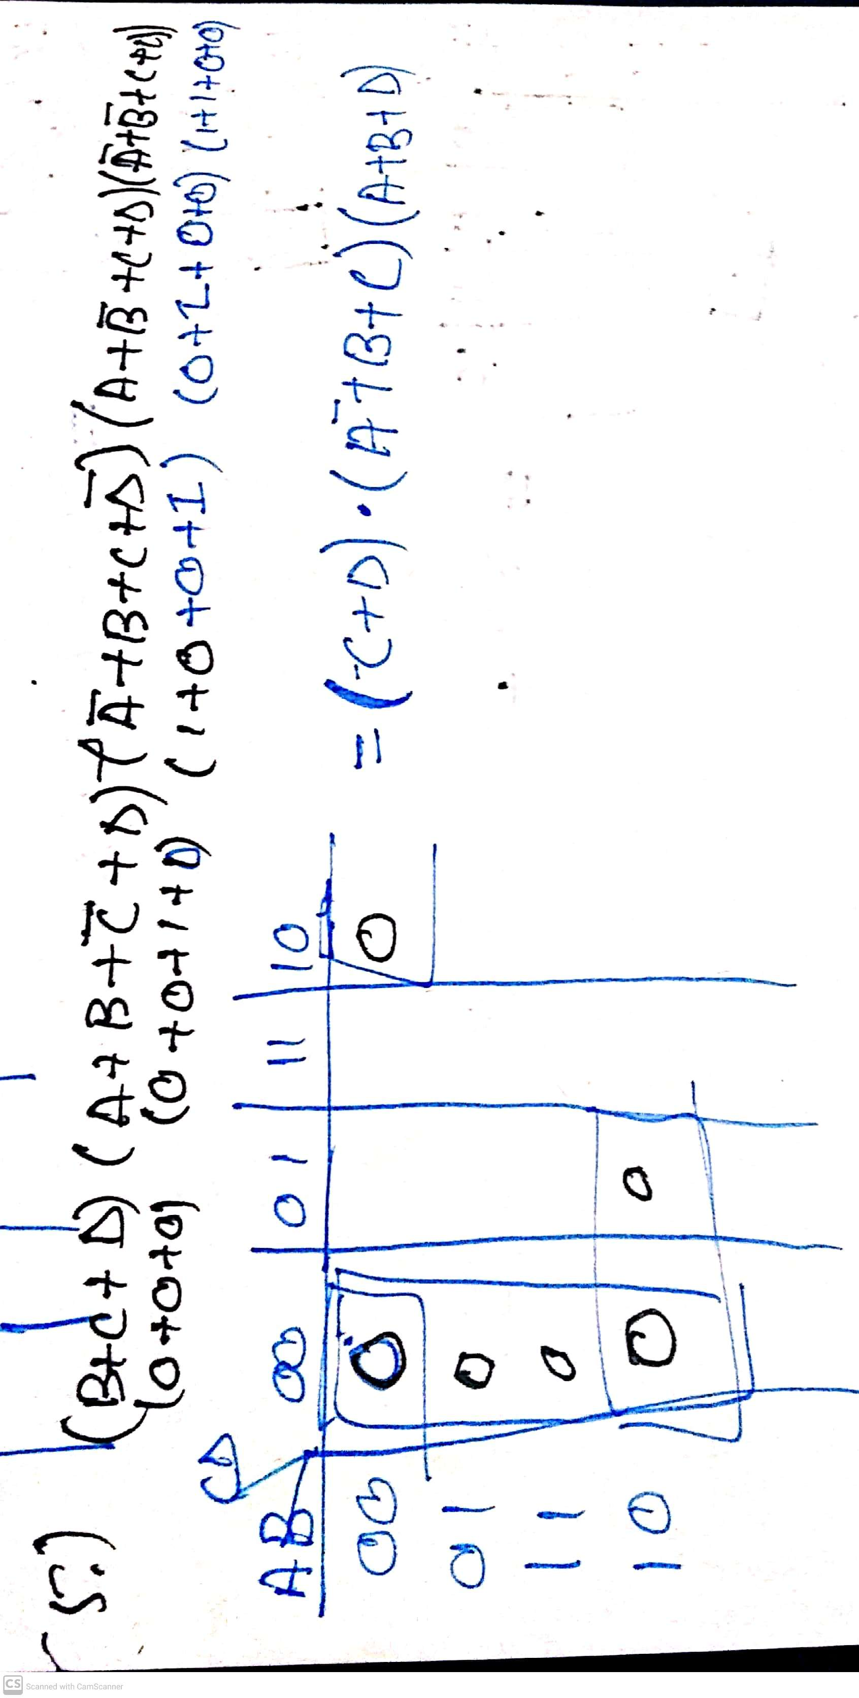

**Question No 6**

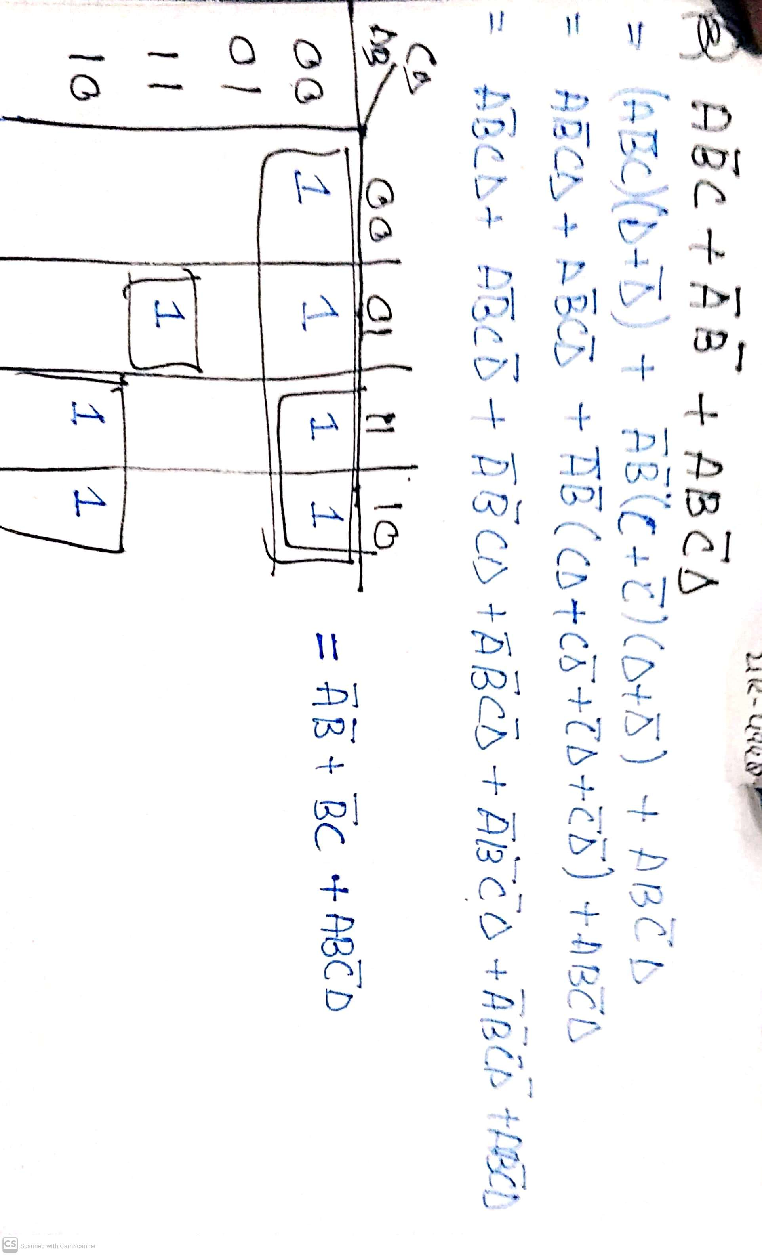

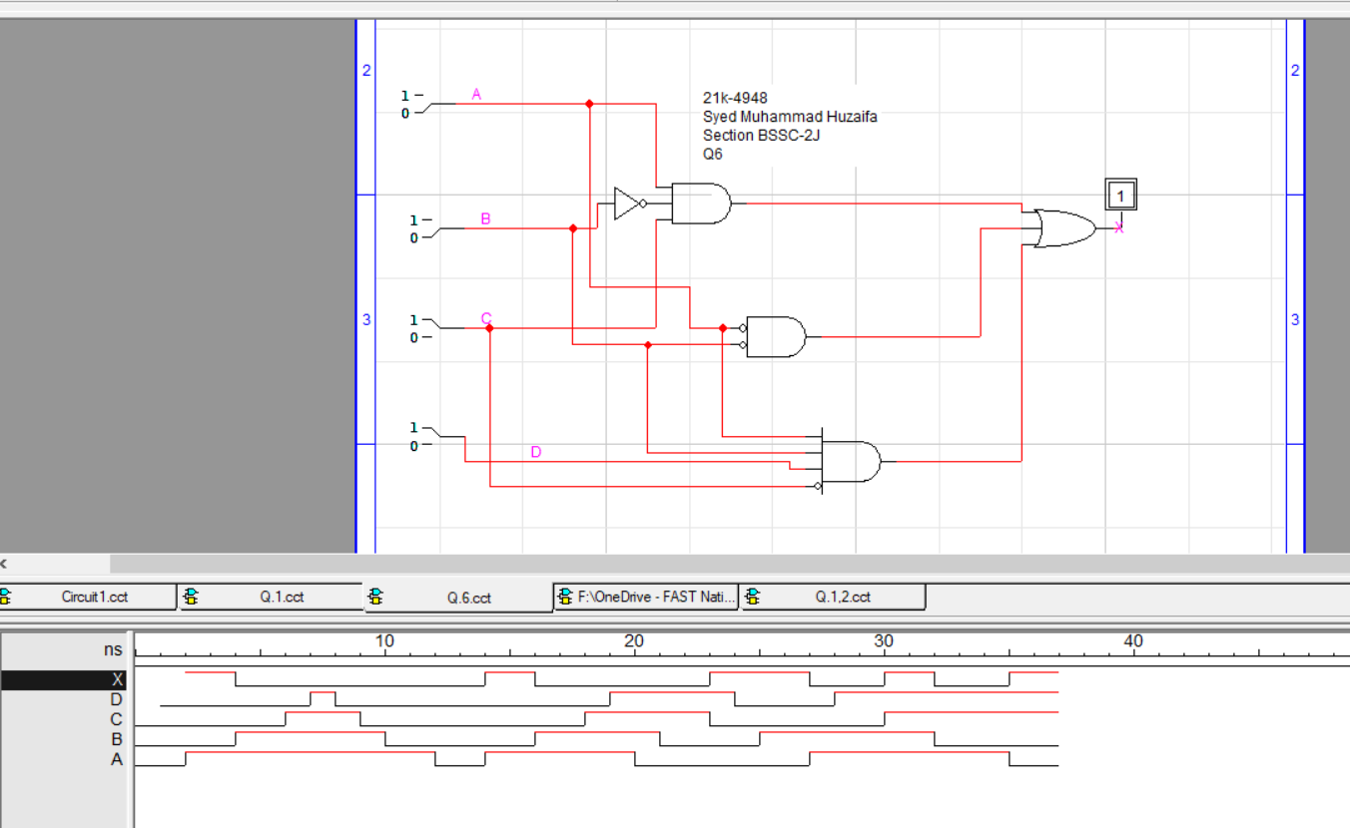

**Question No 7**

